Participants’ Past Experiences & Thoughts about Future Sexual Activity
The demographics and attitudes portions of the Pre-Test consist of 12 multiple-choice and check-all-that-apply questions about participants’ experiences and thoughts about sexual activity. Participants could skip questions by selecting “Prefer not to answer”.
Of the 10 participants who answered these questions on the Pre-Test,
- all 10 (or 100% of) participants reported that they have never had oral, vaginal, or anal sex
- none of the participants reported that they have ever caused a pregnancy or have ever been pregnant
- none of the participants reported that they have ever had sex under the influence of alcohol or other drugs

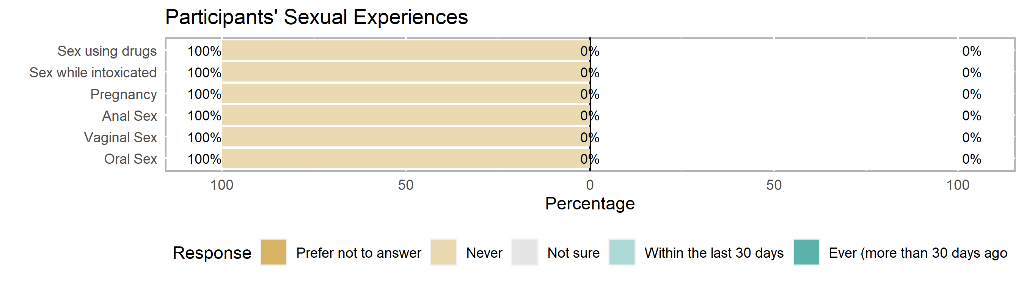
The last time participants had sex, they reported

Of the 9 participants who answered these questions on the Pre-Test,
- all 9 (or 100% of) participants agreed that they would be prepared to say no if they did not want to have sex or if someone wanted to have sex with them without a barrier method. (*Not shown: one participant accidentally took the Post-Test instead of the Pre-Test. They disagreed to both of these statements.)
- One participant (11%) reported they were not sure if they would use birth control if they or their partner were worried about getting pregnant.
- One participant (11%) reported they were not sure if they could go to a doctor for birth control.

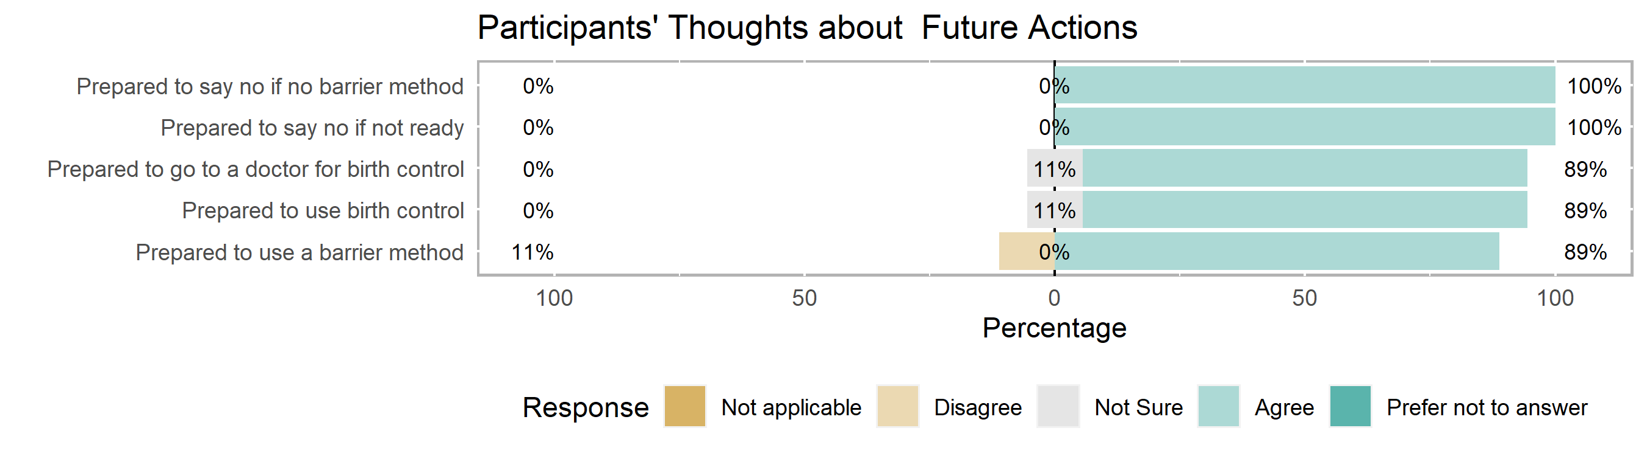

Highlights & Recommendations
The following table includes the number of participants (and percent of the group in parentheses) who answered each question correctly. These were the most difficult questions for your group with recommendations from your TA provider about where to focus lessons:

 | Participants who answered correctly
Question* | Pre-  Test | Post-  Test | Notes
Q34: True or False? Water-based lubricants can cause latex condoms to break. | 1 (10%) |  | 4 participants were not sure.
Q36: True or False? You can get emergency contraception (like Plan B) without a prescription. | 2 (20%) |  | 6 participants were not sure.
Q25: What is PrEP (Pre-Exposure Prophylaxis)? | 3 (30%)
Q35: True or False? Emergency contraception (like Plan B) can be taken up to 5 days (or 120 hours) after having unprotected sex in order to prevent pregnancy. | 4 (40%)
Q24: Which of the following is FALSE about consent? | 4 (40%) |  | 1 participant (incorrectly) thought that someone who is incapacitated by alcohol or drugs can give consent freely.
Q31*: If used correctly, withdrawal (or pulling a penis from a vagina before ejaculating) is effective in protecting people from which of the following? (Check all that apply: Neither pregnancy nor STIs.) | 2 (20%) |  | 5 participants (incorrectly) thought that withdrawal could prevent pregnancy. 4 participants (incorrectly) thought withdrawal could prevent STIs.
Q29*: If used correctly, an external/male condom made out of lambskin (that covers a penis or sex toy) is effective in protecting people from which of the following? (Check all that apply: Pregnancy only.) | 4 (40%) |  | 4 participants (incorrectly) thought that lambskin condoms cannot prevent pregnancy nor STIs. 3 participants (incorrectly) thought lambskin condoms could prevent STIs.
Q26*: If used correctly, abstinence (or choosing not to have sex) is effective in protecting people from which of the following? (Check all that apply: Pregnancy & STIs.) | 7* (70%) |  | 4 participants correctly identified that abstinence prevents pregnancy. 5 participants correctly identified that abstinence prevents STIs.
Q28*: If used correctly, an external/male condom made out of latex, polyurethane, or polyisoprene (that covers a penis or sex toy) is effective in protecting people from which of the following? (Check all that apply: Pregnancy & STIs.) | 7* (70%) |  | 7 participants correctly identified that synthetic condoms could prevent pregnancy. 2 participants correctly identified that synthetic condoms could prevent STIs.
*Participants were able to check-all-that-apply for some questions to earn partial or full credit.

Appendix A

Participants’ Knowledge about Sexual & Reproductive Health
The knowledge portion of the Pre-Test consists of 16 short-answer, multiple-choice, check-all-that-apply, and true/false questions about relationships, birth control (e.g., IUD, implant, shot, ring, patch, pill), and barrier methods (e.g., condoms, dental dams). Participants could earn partial credit on check-all-that-apply questions for a total of 17 possible points*.

- Range of scores: 18% to 88% correct
- Median score: 38% correct
- Mean score: 8 out of 17 possible points* or 45% correct
(right skew: higher-scoring outliers pulling the distribution to the right)
- Mode: tri-modal
- Standard deviation: 23% (quite the/some spread of scores)

Appendix B

Participants’ Demographics (for reporting purposes to the Office of Population Affairs)
Reach for: PAYC021621
Demographics |  | Count
Gender
 | Male | 6
 | Female | 4
 | Transgender | 0
 | Did not identify (?) | 0
 | Gender not reported | 0
Race
 | White | 0
 | Black | 9
 | Asian | 0
 | Alaska Native | 0
 | Native Hawaiian | 0
 | Multiracial | 1
 | Race not reported | 0
Age (years)
 | 12 | 5
 | 14 | 5
Grade
 | 6th Grade | 3
 | 7th Grade | 2
 | 8th Grade | 4
 | 9th Grade | 1
Note: n=10; one participant took the Post-Test instead of the Pre-Test thus skipped the
demographics portion of the survey.
One out of 11 participants took the Post-Test instead of the Pre-Test thus skipping the demographics portion of the survey.
There were also 2 participants with the same initials and birthdate but different genders. This is either the same person or fraternal twins:
 | IP Address | Time Spent
P1 | 107.77.233.4 | 1:34 to 1:47 | (13 min)
P9 | 107.77.236.113 | 1:43 to 2:08 | (25 min)

Because of the different IP addresses (thus different devices) and slight overlap in time, I’d conclude that these are fraternal twins. Also, the first participant to take the Pre-Test did so very quickly and scored higher. There would be little reason for this person to take the Pre-Test again, take longer, and perform more poorly.

- While the group is evenly split by age, participants come from many grade-levels. This may impact individual understanding and group rapport, if participants do not regularly interact with one another.
- Two participants reported LGBQ as their sexual identity. One participant reported a sexual identity not listed in the demographics questions: Pan/Poly. Be aware of language and activities that normalize heterosexual and/or monogamous behavior.
- For mandatory reporting purposes, # participants reside outside of Alamance County in the following counties:

